Lesson Specifics
AKS:
5MA.D.8, 5MA.A.5
IOA:
- 8.d discover and explain how the volume of a right rectangular prism can be found by multiplying the area of the base times the height to solve authentic, mathematical problems (5.GSR.8.4)
- 5.a write, interpret, and evaluate simple (up to two operations) numerical expressions involving whole numbers with or without grouping symbols to represent actual situations (5.NR.5.1a)
QPTS: Modeling and Practice, Problem Solving | Materials:  Chart paper  Grid Paper  Formative  Pencils  Paper
MP Expectation(s):
5.MP.1 Make sense of problems and persevere in solving them.
Learning Target: I can determine the volume of a right rectangular prism by multiplying the area of the base times the height to solve real world problems.
Activating Strategy
Number Talk Strategy: Breaking Factors in Smaller Factors, pg. 284 Number Talks (Sherry Parrish)
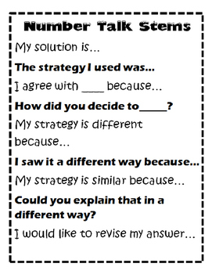
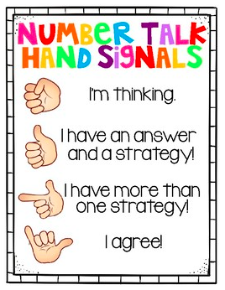
The following number talks consist of problems that focus on breaking basic facts into smaller factors.

4 x 3 x 4
2 x 2 x 12
8 x 3 x 2
2 x 2 x 3 x 4

Click HERE for a summary of how to facilitate a Number Talk.
Mini-Lesson
Background/Prior Knowledge: “We have learned in 3rd and 4th grade that we can find the area of a figure by multiplying the length times the width.”

Teaching Point/Purpose: “Today we are going to find the area of a right rectangular figure and multiply it by the height of the figure to determine its volume.”

Teaching:
The teacher will think aloud …
The engineering club at Peachtree Ridge High School wanted to build a fish tank for a new restaurant in town. The restaurant told the students that they have a designated area for the tank and the fish tank needs to be 5 ft tall. Here is the area that the fish tank needs to cover:
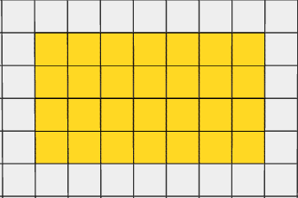
If each square represents one foot, what is the volume of the fish tank?

“We learned in 3rd and 4th grade that we can find the area of a rectangle by counting all of the square units or by multiplying the length times the width. I see that the length, or the base, of the fish tank in the floor plan is 7 feet and the width is 4 feet. 7 feet times 4 feet is 28 square feet. I can check my math by counting the squares to make sure.” Teacher counts square feet. “Yes, I am correct; the area of the fish tank is 28 square feet.”

7 feet long
4 feet
wide

“I know the engineering team is building a fish tank. A fish tank is a 3 dimensional figure. I have only figured out the base (or bottom) of the fish tank which accounts for 2 dimensions, the length and width. I know the fish tank is 5 feet tall. I could look at this as 5 layers of 28 square units or (5 x 28) to determine the total amount of space or volume of the fish tank.”

Teacher models setting up multiplication problem.
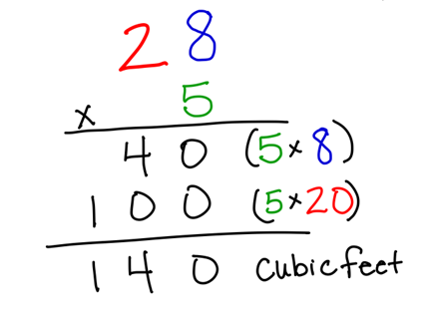

I can use partial products to determine the product of the base times the height of the fish tank. 5 times 8 is 40. 5 times 20 is 100. When I add my two partial products together I get a total of 140 cubic feet, so the fish tank is 140 cubic feet.

When trying to determine the volume of a right rectangular figure, I see I can multiply the length by the width to determine the base, and then multiply the base times the height. I can show that I multiplied the length and width together first with parenthesis like this:
(7x 4) x 5

Active Engagement:
The engineering club wants to build a small container to hold dog treats. Here is a sketch of the bottom of the treat container:
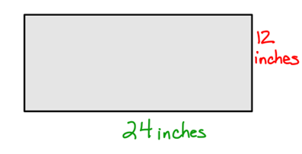

If the container is 10in tall, what is the volume of the container? What expression can you use to show how you calculated the volume?

Teacher allows students to work with a partner to determine the volume. The teacher will observe the students to ensure that students are:
- determining the area of the base.
- providing an expression to show how they determined the volume.
- calculating volume correctly.
- using correct terminology such as square inches to denote area of the base and cubic inches for volume.

Link: “Remember, you can determine the volume of a right rectangular prism by finding the area of the base and then multiplying the base by the height.”
Differentiated Small Groups
Formative Assessment: Khloe’s Xbox Dilemma

Small group collaboration…
Student Task 1:
- The Birds (adapted from Illustrative Mathematics)
Student Task 2:
- Rolling Rectangular Prisms (Adapted from GaDOE)
  - Task can be differentiated by using various sided dice.

Teacher-led small group….
Small Group Instructional Moves (8.c & 8.d)
Summarizing
Hot mic: Ask students to interview a partner using one or all the questions below. Choose one student to “report” out to the class.
- What did you learn about the dimensions of right rectangular prisms and how they can be used to determine the volume?
- How can we use area to help us find the volume of a right rectangular prism?
- How can we determine the height if we only know the base and volume? For example, if the base of a figure is 12 square units and the volume is 24 cubic units, what could the height be?

